MAD & PWA LAB

Practical 1

Name : Varun Gupta

Class : D15 B

Roll No. : 18

AIM : Installation and Configuration of Flutter Environment.

THEORY :

Flutter is an open-source UI toolkit by Google for building natively compiled applications for mobile, web, and desktop from a single codebase. Based on the Dart programming language, it offers pre-designed widgets for creating interactive UIs. To use Flutter, the development environment must be set up by installing the Flutter SDK, configuring an IDE like Android Studio or Visual Studio Code, and setting up an emulator or physical device for testing.

System requirements include Windows 10 or later (64-bit) with 10 GB free space for Windows users, macOS 10.14 or later with Xcode for iOS development on macOS, and a 64-bit Linux distribution with dependencies like bash and libstdc++ 6.4 or newer. To install Flutter, download the stable version from the official website, extract it, and add the path to the system's environment variables. Configure an IDE, commonly Android Studio, and set up an emulator or iOS Simulator. Running `flutter doctor` in the terminal verifies installation and checks for missing dependencies. Once configured, Flutter is ready for cross-platform app development.

Installing the Flutter SDK

Step 1: Download the installation bundle of the Flutter Software Development Kit for windows.

To download Flutter SDK, Go to its official website https://docs.flutter.dev/get-started/install ,

you will get the following screen.

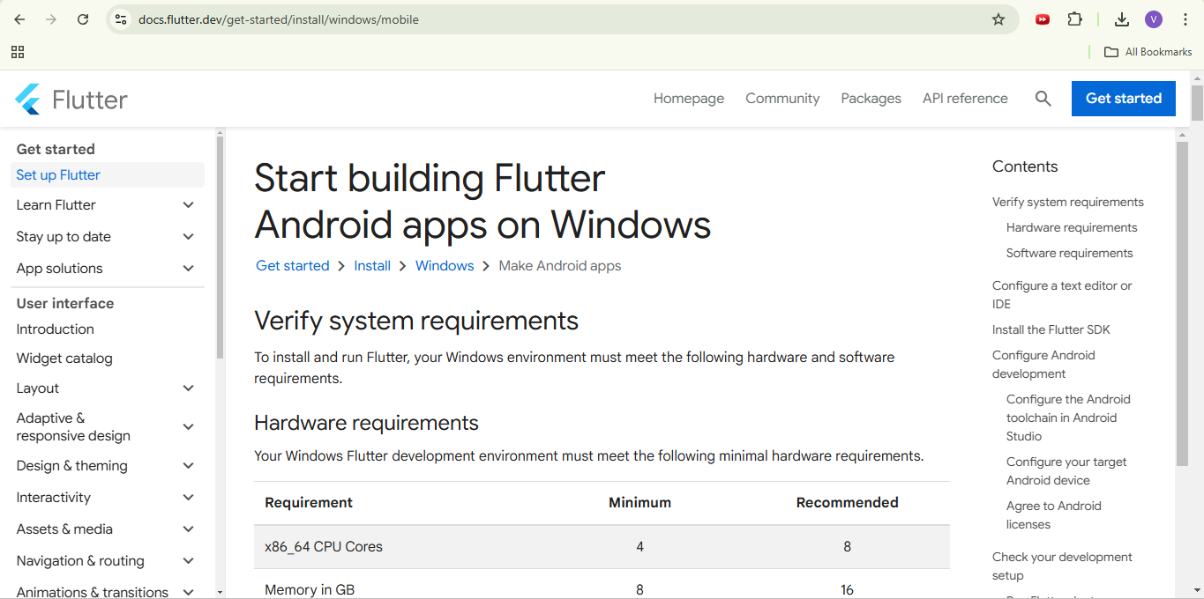

Step 2: Next, to download the latest Flutter SDK, click on the Windows icon. Here, you willfind

the download link for SDK.

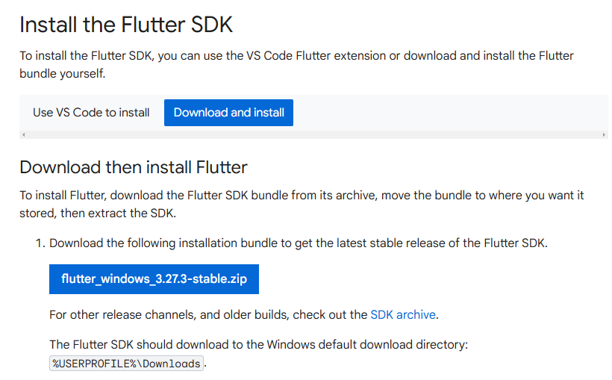

Step 3: When your download is complete, extract the zip file and place it in the desired

installation folder or location.

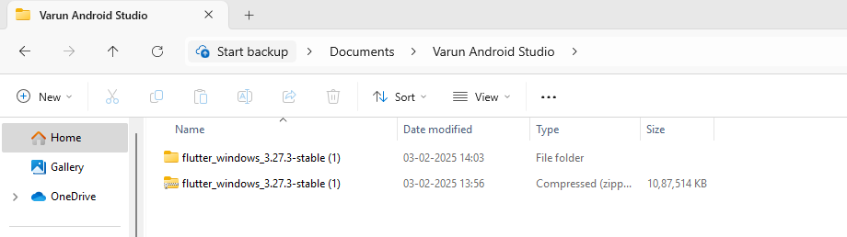

Step 4: To run the Flutter command in regular windows console, you need to update the system

path to include the flutter bin directory. The following steps are required to do this:

Step 4.1: Go to MyComputer properties -> advanced tab -> environment variables. You will get

the following screen.

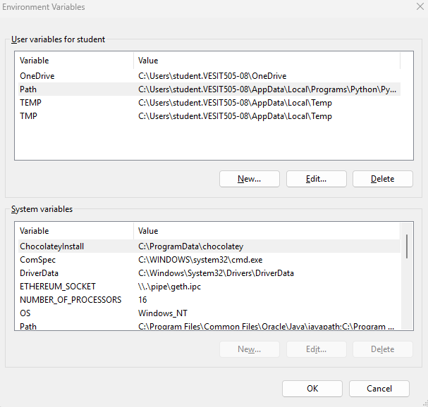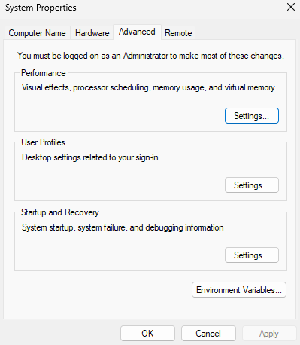

Step 4.2: Now, select path -> click on edit. The following screen appears

**Step 4.3:** In the above window, click on **New** → write the path of the Flutter bin folder in the variable value → **OK** → **OK** → **OK**.

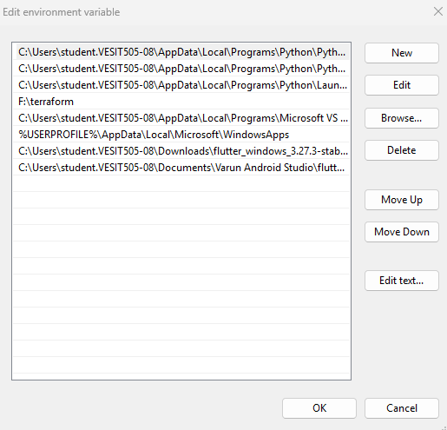

Step 5: Now, run the $ flutter command in command prompt.

Now, run the $ flutter doctor command. This command checks for all the requirements of

Flutter app development and displays a report of the status of your Flutter installation.

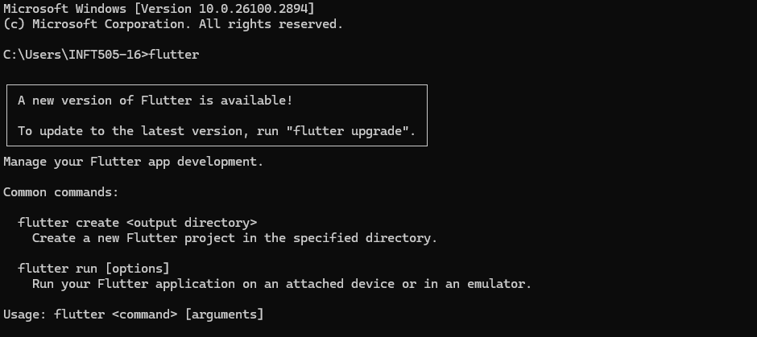

Step 6: When you run the above command, it will analyze the system and show its report, as

shown in the below image. Here, you will find the details of all missing tools, which required to

run Flutter as well as the development tools that are available but not connected with the device.

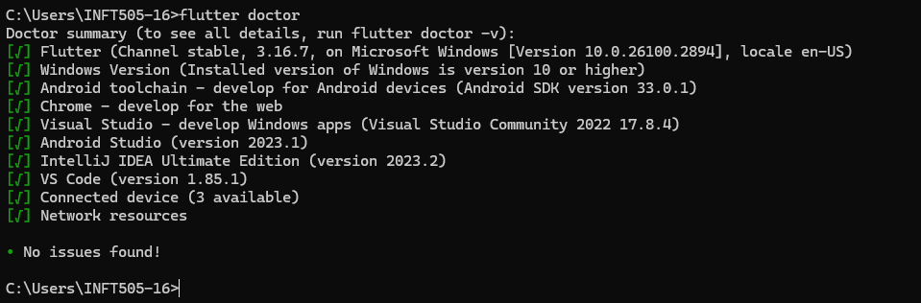

Step 7: Install the Android SDK. If the flutter doctor command does not find the Android SDK

tool in your system, then you need first to install the Android Studio IDE. To install Android

Studio IDE, do the following steps.

Step 7.1: Download the latest Android Studio executable or zip file from the official site.

Step 7.2: When the download is complete, open the .exe file and run it. You will get the

following dialog box.

Step 7.3: Follow the steps of the installation wizard. Once the installation wizard completes, you

will get the following screen.

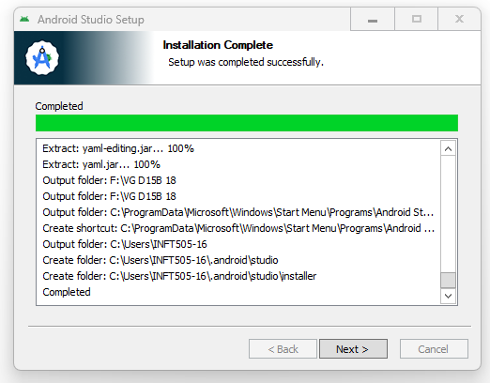

Step 7.4: In the above screen, click Next-> Finish. Once the Finish button is clicked, you need

to choose the 'Don't import Settings option’ and click OK. It will start the Android Studio.

run the $ flutter doctor command and Run flutter doctor --android-licenses command

Step 8: Next, you need to set up an Android emulator. It is responsible for running and testing

the Flutter application.

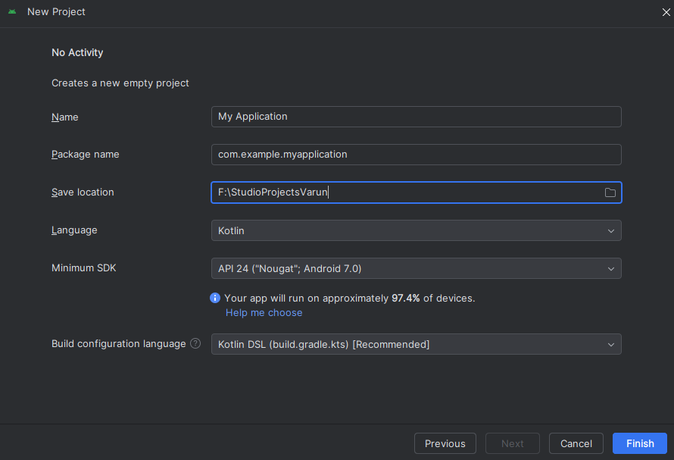

Step 8.1: To set an Android emulator, go to Android Studio > Tools > Android > AVD Manager

and select Create Virtual Device. Or, go to Help->Find Action->Type Emulator in the search

box. You will get the following screen.

Step 8.2: Choose your device definition and click on Next.

Step 8.3: Select the system image for the latest Android version and click on Next.

Step 8.4: Now, verify the all AVD configuration. If it is correct, click on Finish. The following

screen appears

Step 8.5: Last, click on the icon pointed into the red color rectangle. The Android emulator

displayed as below screen.

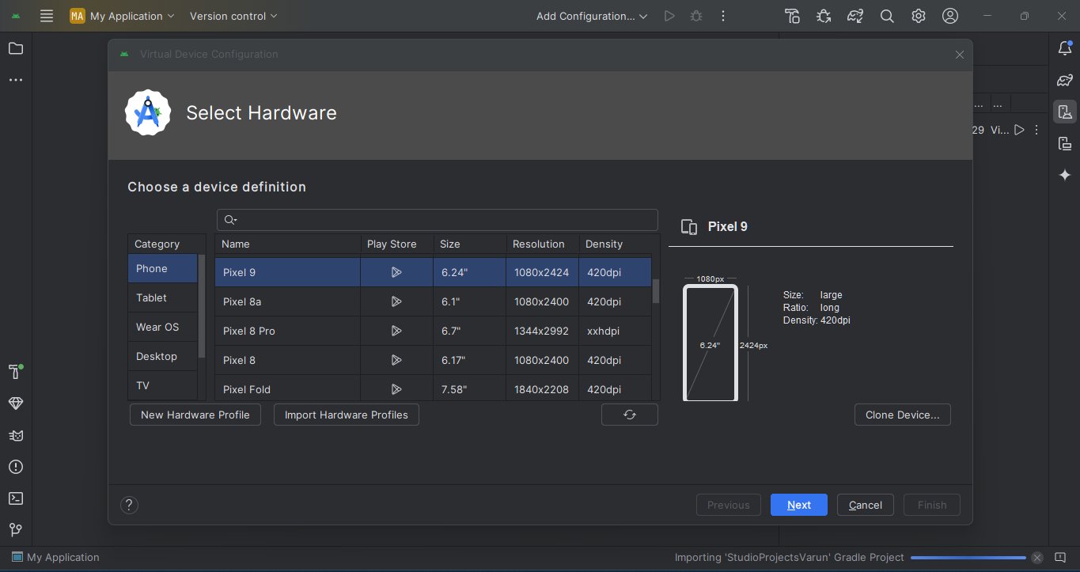

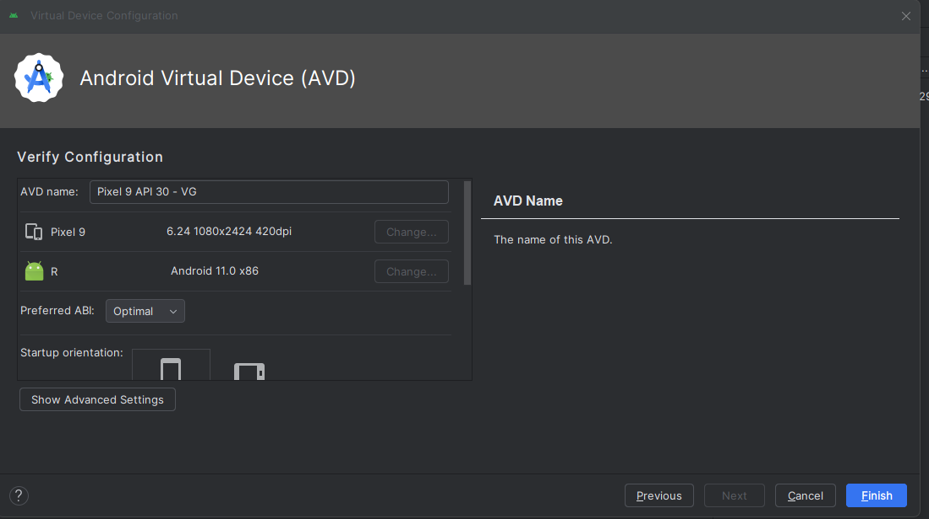

Step 9: Now, install Flutter and Dart plugin for building Flutter application in Android Studio.

These plugins provide a template to create a Flutter application, give an option to run and debug

Flutter application in the Android Studio itself. Do the following steps to install these plugins.

Step 9.1: Open the Android Studio and then go to File->Settings->Plugins.

Step 9.2: Now, search the Flutter plugin. If found, select Flutter plugin and click install. When

you click on install, it will ask you to install Dart plugin as below screen. Click yes to proceed.

Step 9.3: Restart the Android Studio

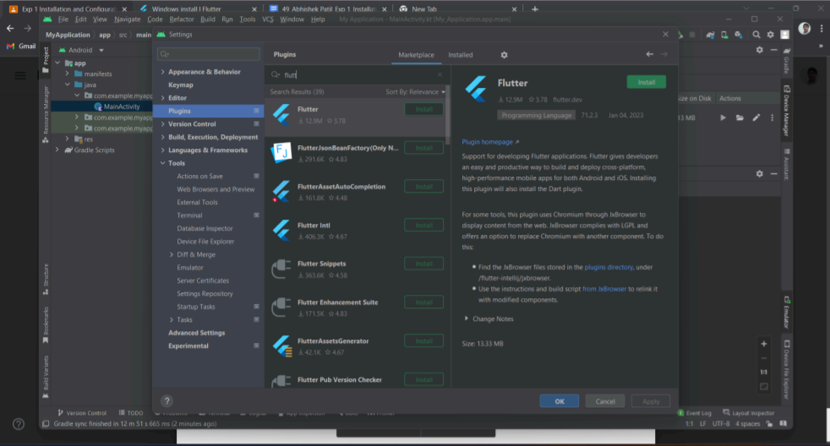

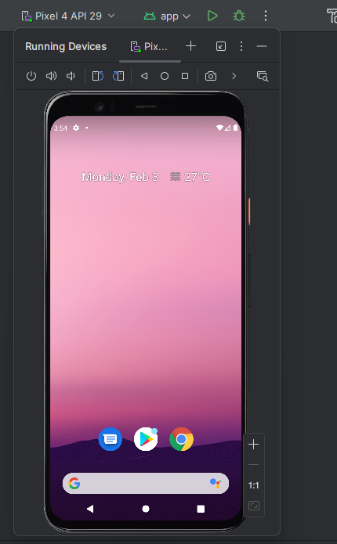

Conclusion:

Setting up the Flutter environment is essential for cross-platform app development. Proper

installation of the Flutter SDK, IDE, and dependencies ensures a smooth workflow. A

well-configured setup enables efficient development, testing, and deployment of

high-performance applications across multiple platforms.